**Using ECS through EC2**:

Just like hosting can be done through server or serverless, eg ec2 is using server and hosting via s3 Is serverless.   
here also running a container can be done via server ie., ec2 and serverless I,e., fargate

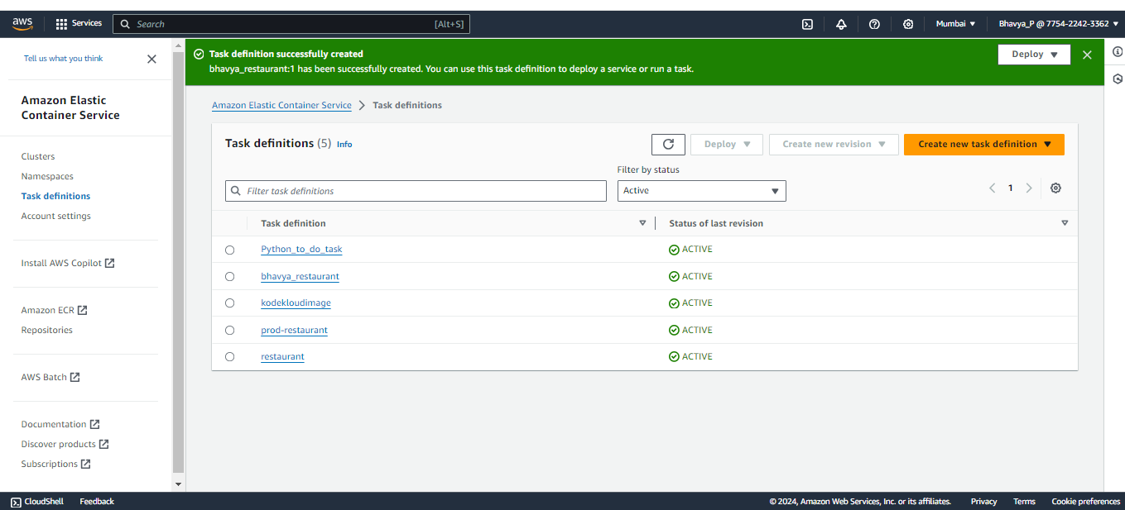

Creating task definition is similar to writing dockerfile  
  
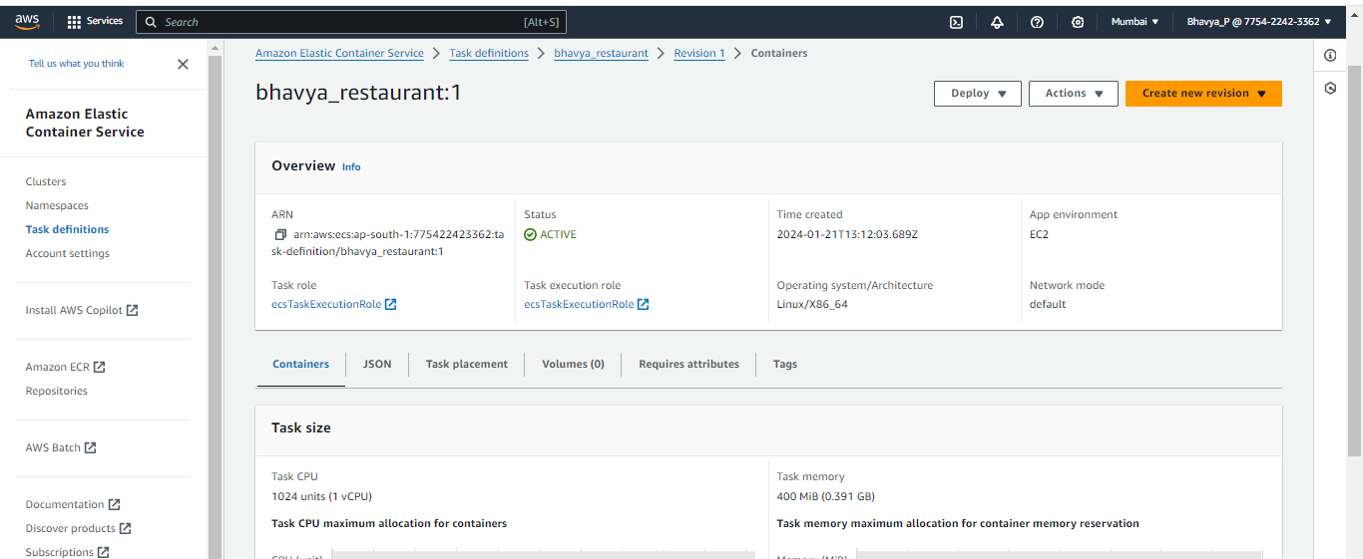

Container details:  
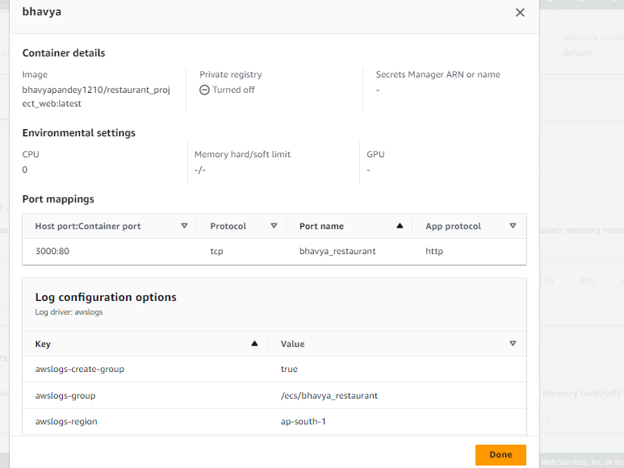

ECR role has following permission  
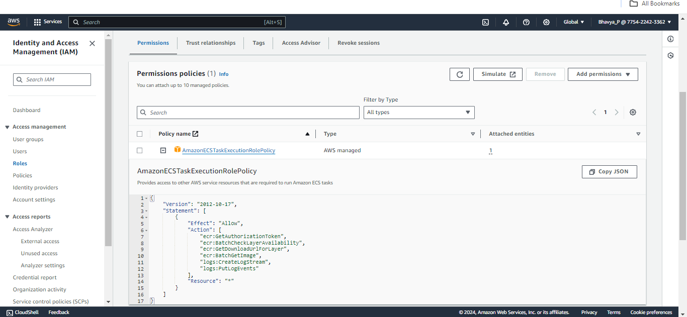

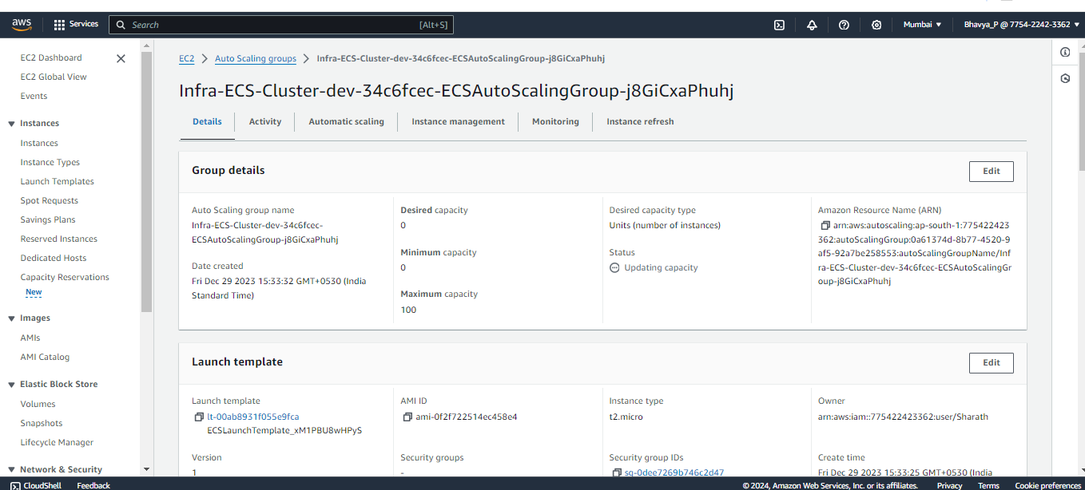  
Auto scaling group for ECS Cluster, while running the task make the desired capacity to 1 or let it be 0.

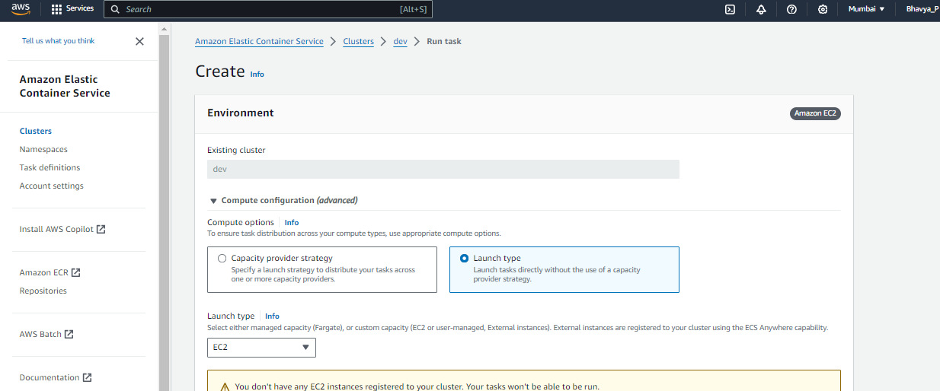  
Need to run a new task, for that container

And then through container or ec2 public ipv address can see your hosted application.